Diary Entry 4 Trivia: Explosion edition

**4 .0 Introduction**

The team were required to develop a game where the players have to work together to defuse a ‘bomb’, the game needs to include a time limit where the bomb blows up and the players lose if they take too long.  
  
**4.1 Materials**

|  |  |
| --- | --- |
| Material: | How the team used it: |
| Google Docs | The team used google docs to create ideas for the different trivia questions that would be in the game (Table 1). |

**4.2 The Rules**

The game is a trivia-based game under a time constraint, where the questions get harder the closer the player gets to the centre.

* Players must get into teams consisting of 1-4 players
* If your team answers a question correctly then they get +5 seconds
* Each team has 8 minutes to start with
* The timer starts counting down when the game starts in a speed chess style – so the timer stops at the end of the round and then continues at the start of the next round.
* Easy round consists of 5 questions (3 of 5 must be correct to advance)
* Normal round consist of 3 questions ( 2 of 3 must be correct to advance)
* Hard round questions are asked until the time expires or the team answers 3 question incorrectly in a row.
* The team to answer the most question correctly in the centre defuses the bomb and wins

**4.3 Board and Questions**

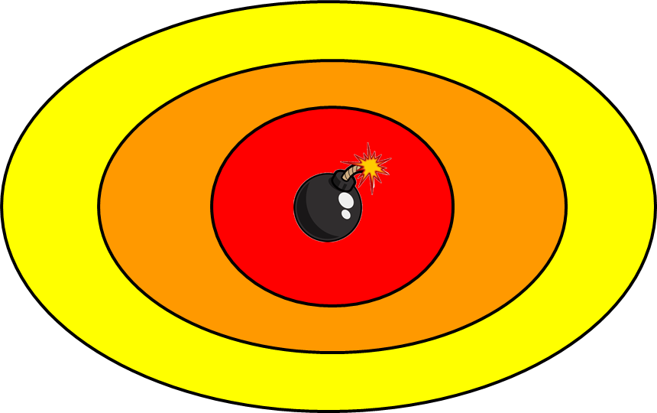

**C**

**B**

**A**

**Figure 1**, Mock-up game board.  [A] The yellow will be the starting stage with easy questions, [B] the orange stage is the middle ground with medium questions, [C] The red is the final stage where you are asked hard questions .

**Table 1** – A table showing some example questions

|  |  |  |  |
| --- | --- | --- | --- |
| **Topic** | **Difficulty** | **Question** | **Answer** |
| Biology | Easy | What is the human body’s largest organ? | The skin |
| Normal | What is the biggest artery in the human body? | The aorta |
| Hard | What are the tiny air sacs in the lungs called? | The alveoli |
| Mathematics | Easy | List out the first 12 multiples of ‘11’ | 11, 22, 33, 44, 55, 66, 77, 88, 99, 110, 121, 132 |
| Normal | How many days are there in 3 years? | 1095 |
| Hard | What is pi to 6 decimal places? | 3.14159 |
| Geography | Easy | What is the largest desert in the world? | Antarctica |
| Normal | What country has the longest coastline in the world? | Canada |
| Hard | What is the highest mountain in North America? | Denali |

**4.4 Play testing**

The team did some internal play testing of the game and decided to change how the final round worked. The final round originally consisted of 2 hard questions, but the team found out that this meant the game in in a tie a lot of the time. So it was changed so the player had to answer as many questions as they could in their remaining time.

The team also did some external playtesting, this went very smoothly as, “The question themselves were quite good and broad” – Muhammed Zulfqar, this was very good feedback as it let the team know that the questions were varied enough. During the play testing the team also learnt that the difficulty of the questions were correct for the category they were put in to.

**4.5 Reflection**

Working in a team on this project went very well as the team split up the work so that different people were doing different tasks at the same time this allowed the team to get the work done much faster and efficiently.

The team worked very well together with all members participating, but the playtesting was still rushed towards the end so only one person play tested the game. In future projects the team needs to try to ensure that the game is play tested by more then one person.

4.6 Team Members and External Play Tester

Team Members:

* Yap Hou Yuen
* James Wilson
* Alexander Lawton

External Play Tester:

* Muhammed Zulfqar